**Screen Sketches**

**Battle of the Worlds**

**Team SB_C_1**

Saishreya Shankar

Aaron Rees

Mithil Shah

Robert Duvall

**STEP 1- READ**

**STEP 2- Functionality**

**Actor:** **Functionality**

Description

**GAME ADMIN:** **Monitors the game to see if there are any defects.**

The game admin will log into the game occasionally to check any defects that the game may produce. If there is a defect they will notify the game designer and game programmer immediately so a fix can be made. The game admin will also be granted access to temporarily shut down the game while any fix is being made. They will also keep player records and ensure no suspicious web activities happen among players.

**GAME PLAYER:** **Log in, choose character and play the game OR create and account**

This is a new user that has decided to sign up to play the game. They have no responsibility of game management. These are the users that the game is made for. They will have access to different characters and armory based on their skill level and will be ranked with other players around the world.

**GAME DESIGNER:** **Models and updates how the game will look and function.**

The game designers job is to keep up with current designing trends and design the game in a way to make it easy for the user. They wll design the account home, game screen, characters and backgrounds. They will create organized designs and hand it to the programmers to follow and code the game accordingly.

**GAME PROGRAMMER: Builds the games and functionality based on the designers idea**

The programmers job is to create the game according to the requirements of the game designers. They will also manage the security of the game and work on updates. They will keep coming up with ways to make the game run smoother and work on constant upgrades. The programmers will code the game and submit it to a game tester before it goes live.

**GAME TESTER:** **Tests the game to see if it works properly.**

Any big company has QA testers to test the functionality, security and reliability of code. The game tester does exactly this. They will take the code from the game programmer and use a test environment to play the game and attempt to break it. If all goes well (game functions decently), they will allow the upgrade to be made by the admin.

**STEP 3- Screen Sketches**

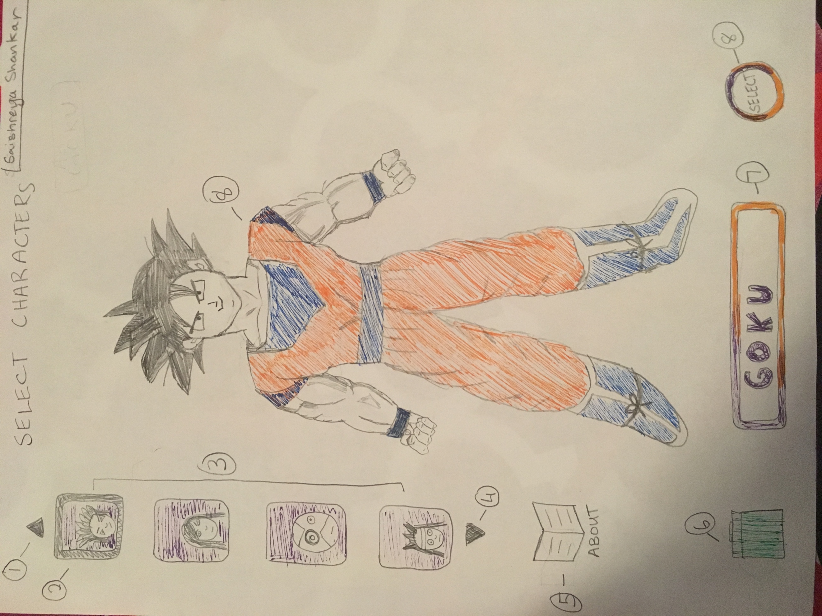 (Character Select Page, Saishreya Shankar)

9

The Character Page let’s players select avatars that are premade from the game they play. A Vertical spinner widget (3) will contain different characters. The user can use the up and down arrows on the screen to navigate through the list(1)(4). A golden border will appear around the character button that is currently selected in the spinner(2). Notice that only the characters head appears in the spinners buttons. When a character is selected, the whole body will appear on the screen (8). When pressing the space bar or on the character itself, the character will make an animated move (such as pulling their sword out, turning to the side, etc…).

A character can also be deleted of the player’s character select menu. This can be done by clicking on the trash icon (6). The character will be archived until the player decides to add the character back. Next to the trash icon

is the character name displayed in a box (7). Next to this box is a select button (9). Once the player has selected a character that they want to play with, this button should be pressed and will take you strait to the character management page. The background is black. The color component is incomplete in sketch due to pending decisions.

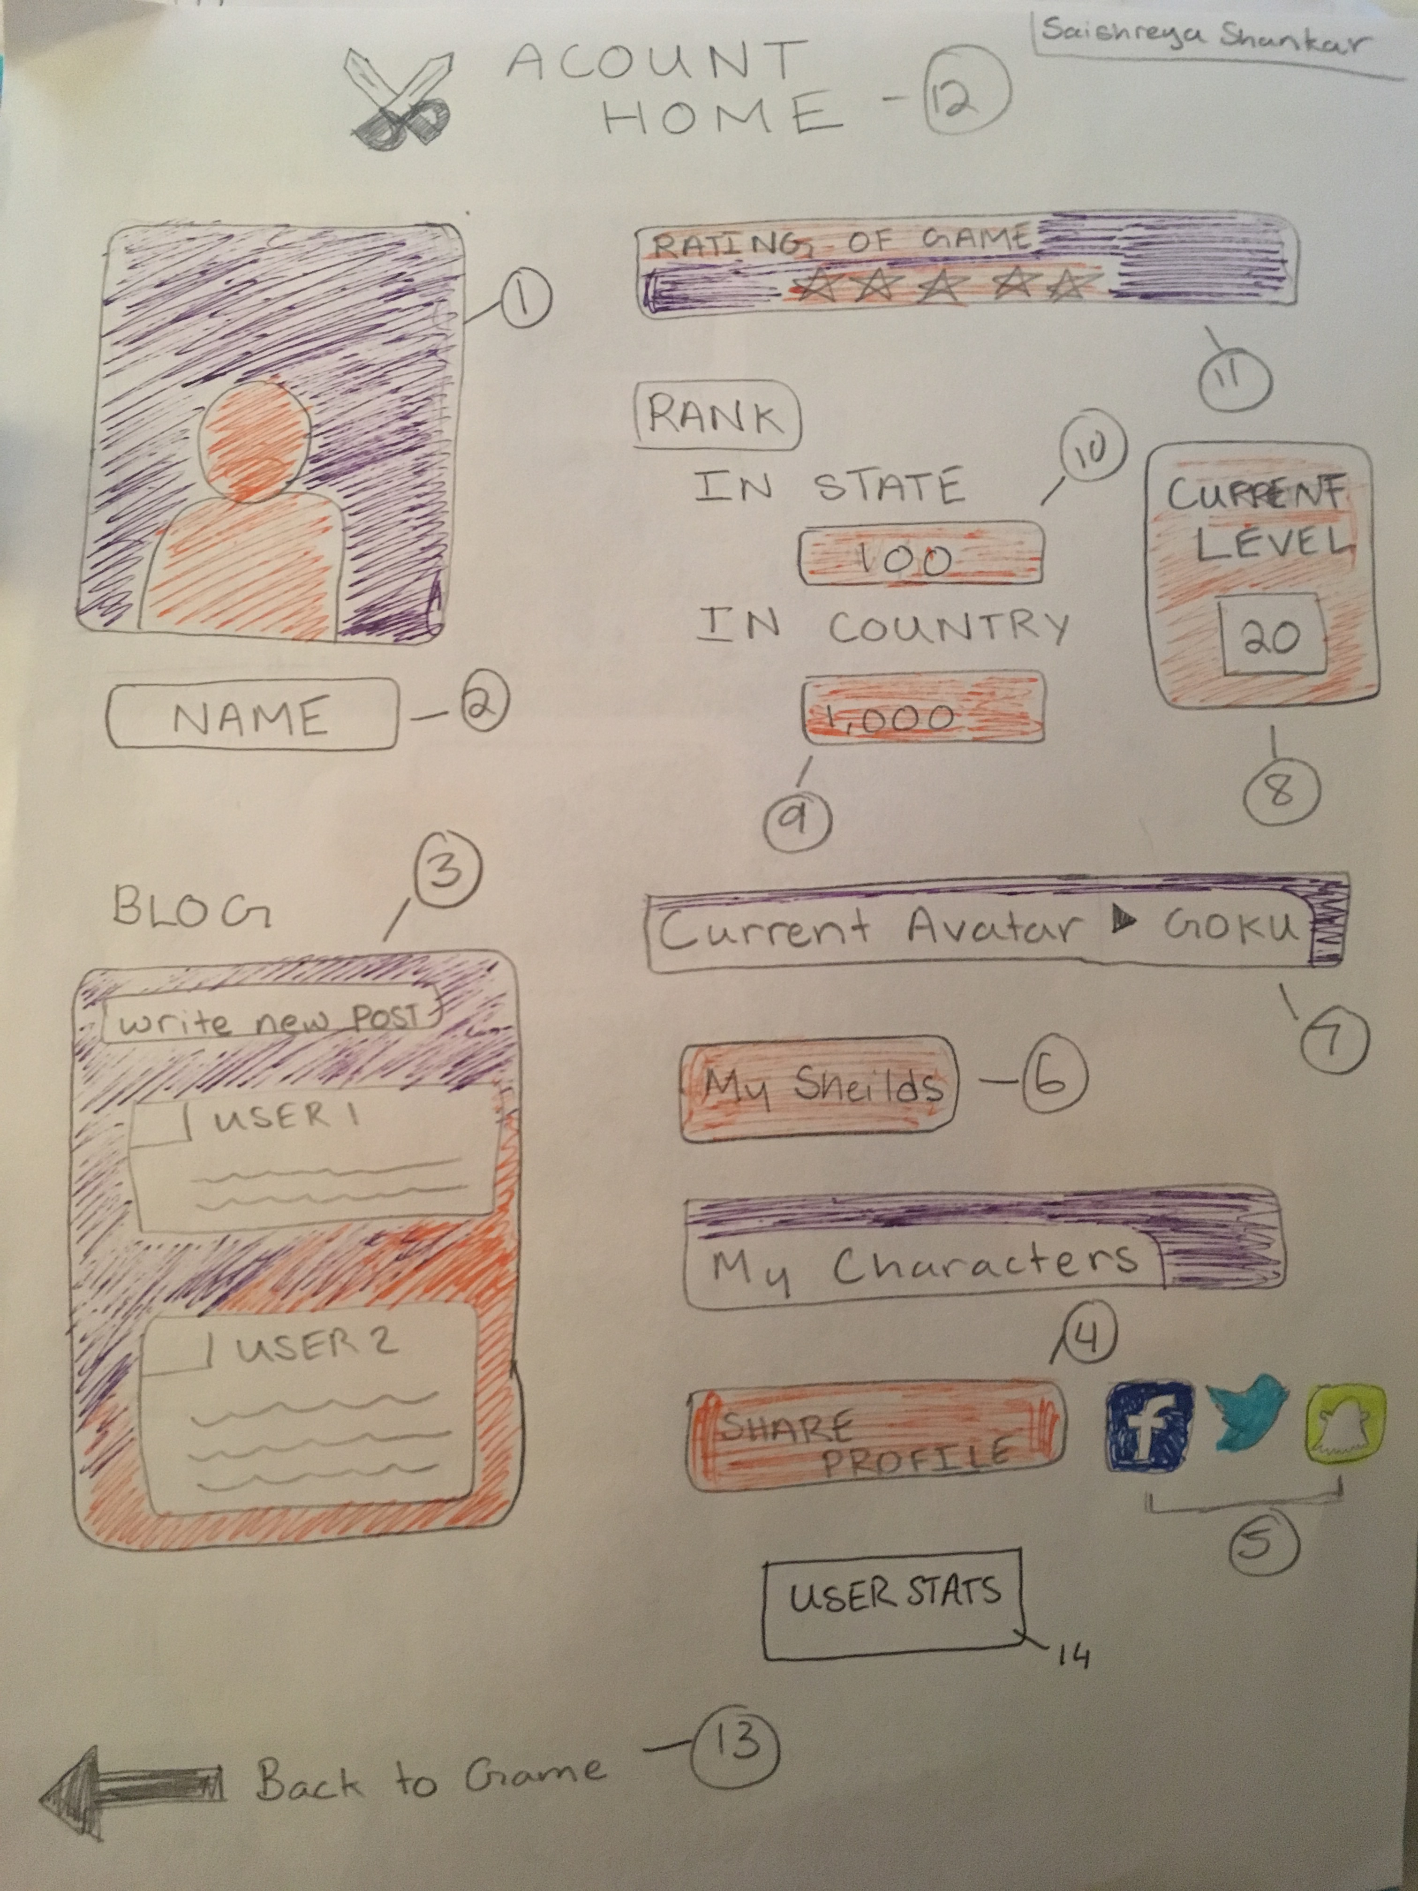

(Account Home Page, Saishreya Shankar)

15

The account home page allows the player to see all of their recent activities related to the game(12). The user can access this page through a link in the default page after logging in. The player can first upload their picture if they choose (1). The default picture will be like it is animated above. They can also edit their name by clicking in the text box (2) and simply type it in. When they press enter, the name will be AutoSaved. In the blog widget, they player will see the most liked and latest blogs by other users, they will also be given a text box to type a post from the widget(3). They user will be given an a widget which they can use to rate the game (11). The rating can be changed anytime and will AutoSaved every time it is changed. There are also the users ranking displayed compared to the state and country (10) (9). The current skill level is also displayed (8). These three cannot be edited or changed. The Current Avatar widget displays the players current character and also cannot be changed (7). The My shields widget provides access to the character management page (6). Next to the Share Profile widget (4), the social media logos can be used to share the players current ranks and skill level (5). The User Stats Button will take the player to the User Stats page when clicked on (14). The Back to Game Arrow will take the player back to the default page (13). Clicking on the My Characters Button will take the player back to the Character Select Page (15). The color component is incomplete in sketch due to pending decisions.

(Character Management Page, Aaron Rees)

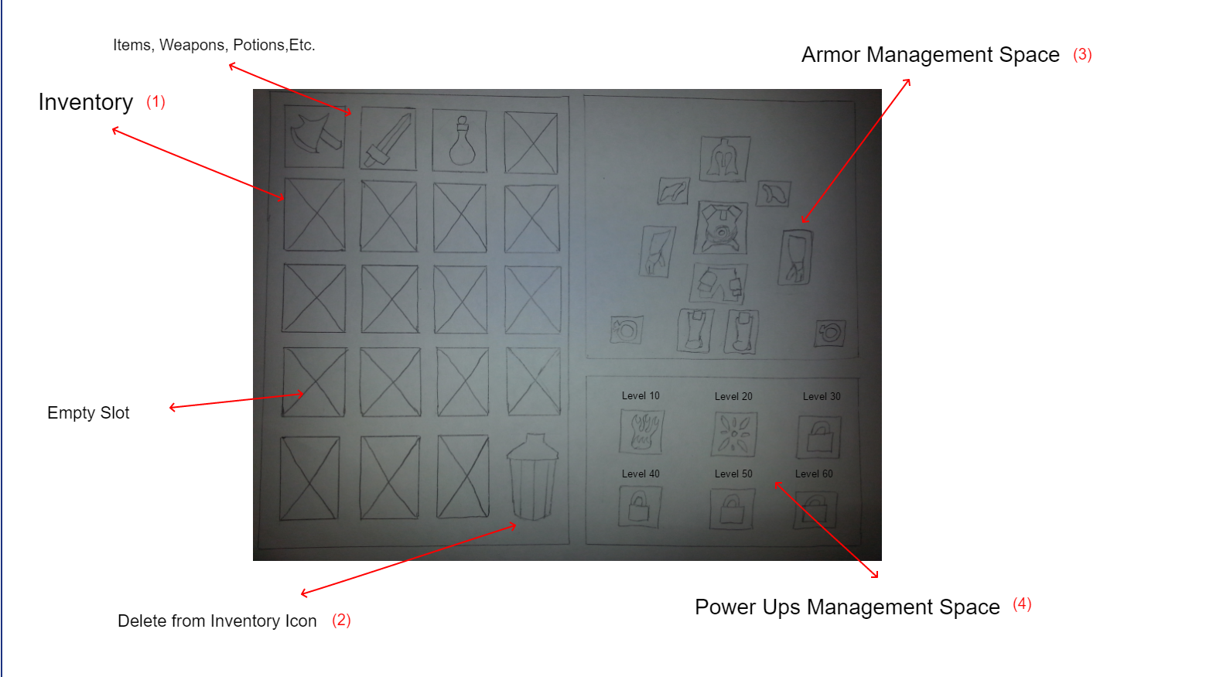

The Character Management Page allows the player to manage the items he/she has acquired while adventuring. The player can click and drag items from the Inventory (1) to other parts of the Character Management Page. If the player acquired items he/she does not need or want, they can delete the item by dragging the item to the Delete from Inventory Icon (2).

The player can equip items to their character by placing it in the appropriate slot from the Inventory to an appropriate spot in the Armor Management Space (3). The player can have up to a total of 11 pieces in the armor management spot.

The player can select which power ups he/she can use by selecting a dropdown box from an appropriate spot in the Power Ups Management Space (4) specified by a symbol for the power up. Power ups not unlocked yet are shown with a padlock symbol.

(Social Media Page, Aaron Rees)

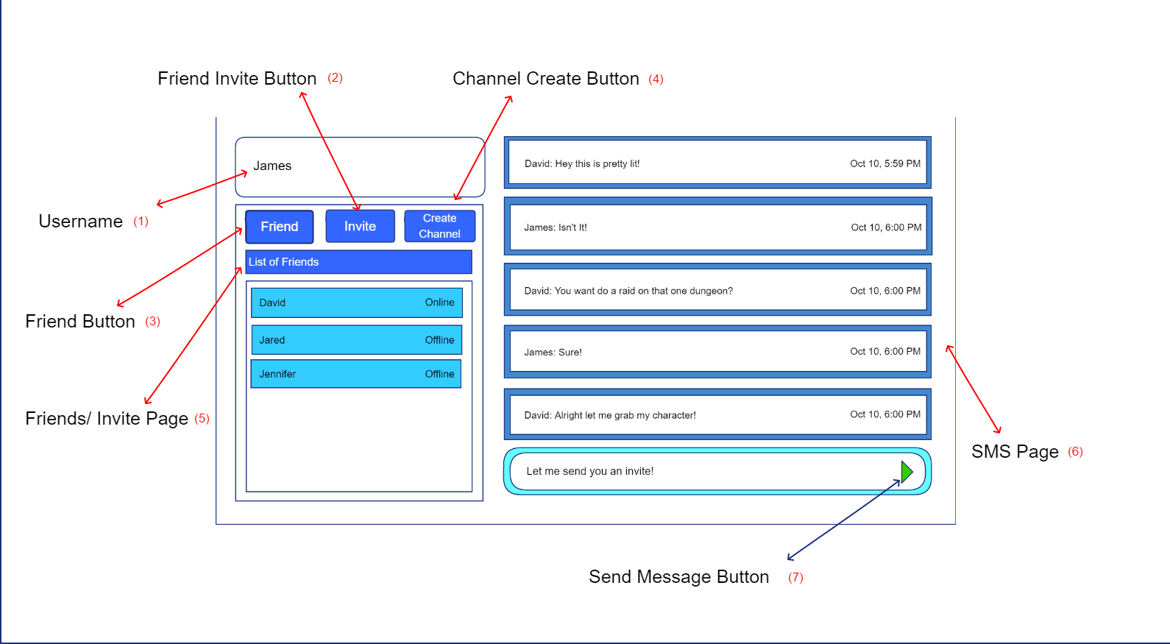

The Social Media Page allows the players to socialize with one another via a chat window. The Social Media Page displays the players name (1) and a list of other players which the player has added to his social media page via a friend invite button (2). The player can control who is in their chat window by “friending” via the Friend button (3) them or by inviting another player into a channel created by the player via the Channel Create Button (4).

The Friends and Invite Page shows the list of friends who are online at the moment and which players are offline (5). The players can then communicate through a chat window via the SMS page (6). By pressing the send message button (7), SMS page the player sends players messages within the chat window. All messages are time stamped to allow players to know when the message was sent.

Robert Duvall

Talent Select Screen

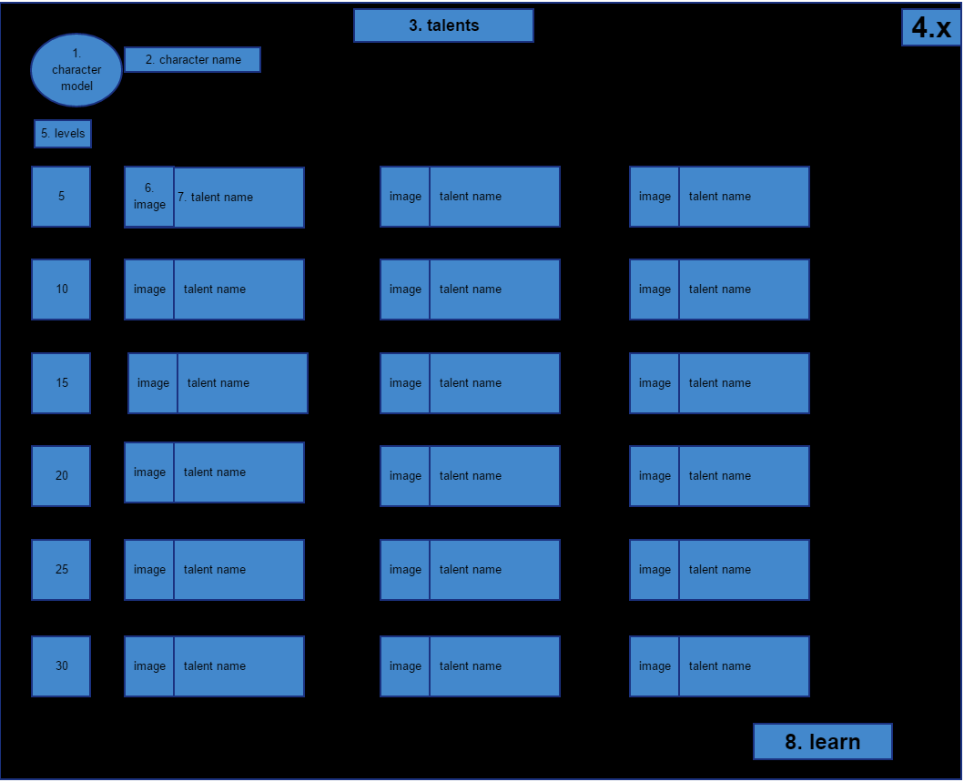

The Talent Select Screen allows the gamer to select between three different talents at specific levels. This screen appears when the user presses on the talent button on the main game screen. The first tier of talents is given at level 5 (5) and each other one is given in increments of 5 levels. On the top right of the screen the character will be able to see their characters model (2) along with their character’s name (2). Each talent will have an image associated with them (6) along with a talent name (7). Once a talent is clicked on, a description of the talent will be displayed on the screen, so the gamer will be able to fully understand what they are choosing before they make their choice. On the top of the page will be a reminder that the gamer is on the correct screen for talents (3). The gamer will also be able to close the screen at any time by pressing the x on the top left of the screen (4), which will put them back at the main game screen. And finally, after the gamer has selected the talent that they want they will be able to save it by clicking on the learn button on the bottom right (8). The learn button will redirect the gamer back to the main game screen.

Robert Duvall, Main Game Screen

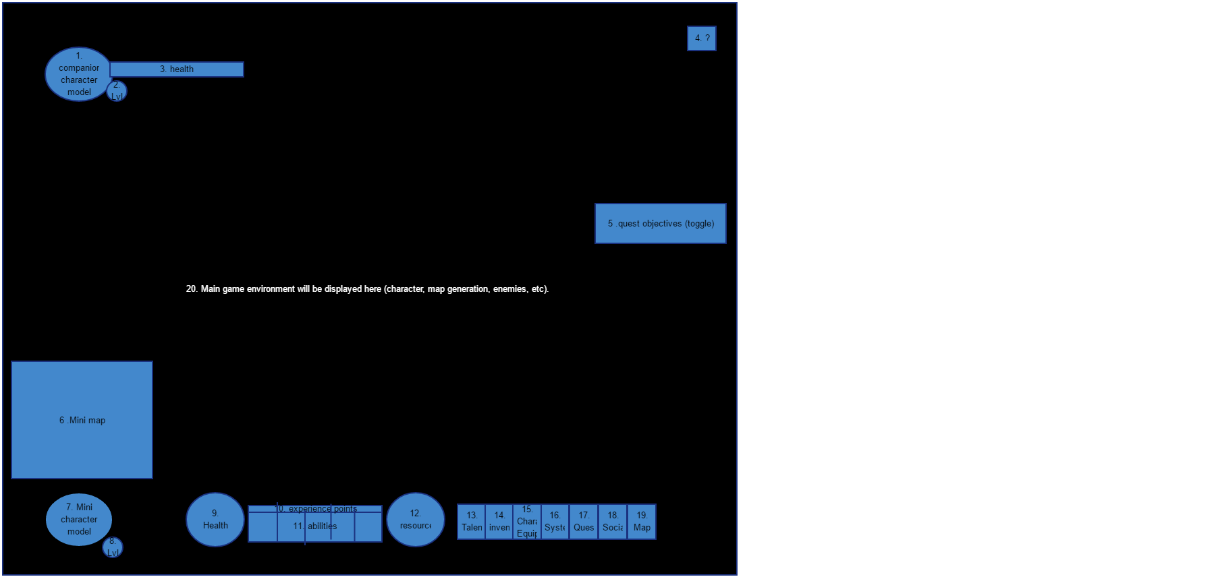The main game screen allows the gamer to move their character throughout the game, picking up quests, leveling, and defeating the enemies before them to get better equipment (20). This main game screen appears once the user has selected a character and presses enter game on the character select screen. They will be able to see a mini map of where they currently are on the lower left hand side of the screen (6) along with a mini version of their character model (7). The character’s level will also be displayed in the bottom left (8). When the gamer has people in his party (invites friends to play on the character select screen), they will be displayed in the top left-hand corner of the screen along with their character model (1), level (2), and health (3). The gamer’s character health will be displayed on the bottom of the screen (9) next to their abilities numbered (11), and with the experience points just right above their abilities (10). Experience points can be gained through quests and defeating enemies and allow the character to level once it reaches the experience points needed to go to the next level. The character’s resource (different for each class) will be displayed on the right-hand side of the abilities and experience points (12). This resource will allow the gamer to use the characters abilities at a cost of resources. The gamer will also have some other buttons to the right of the character resources used to open different screens. The first button will allow the gamer to open the Talent Select Screen, which allows the user to select different talents at certain level or simply see what he/she has chosen (13). The next button is the inventory button that will display an inventory screen of the things the character has looted on their journey (14). The next button is the Character Equipment button which lets the gamer open the character equipment screen to see what equipment the character has on, the different stats they possess, and will allow them to switch gear in and out of the inventory (15). The next button is the Systems button which allows the gamer to open the systems screen where they will be able to change settings, exit the game, log out, etc. (16). The button beside that one will be the quest button (17). This button toggles a quest log and will allow the gamer to not only see what quests the character has, but also allows them to track the quests to see what they have let to do (5). The button to the right of quests is the Social button. The social button opens a window on the bottom right of the screen allowing them to talk to friends, or see what friends are online (18). The last button is the map button. When the gamer presses the map button the whole map will appear on the screen, allowing he/her to see anywhere on the map they desire. Lastly, there will be a little help button in the top right of the screen displayed as a question mark (4). The help button will open up the help screen, which will allow the gamer to open a ticket to report a bug, get in contact with a developer for some help, and open up a FAQ window.

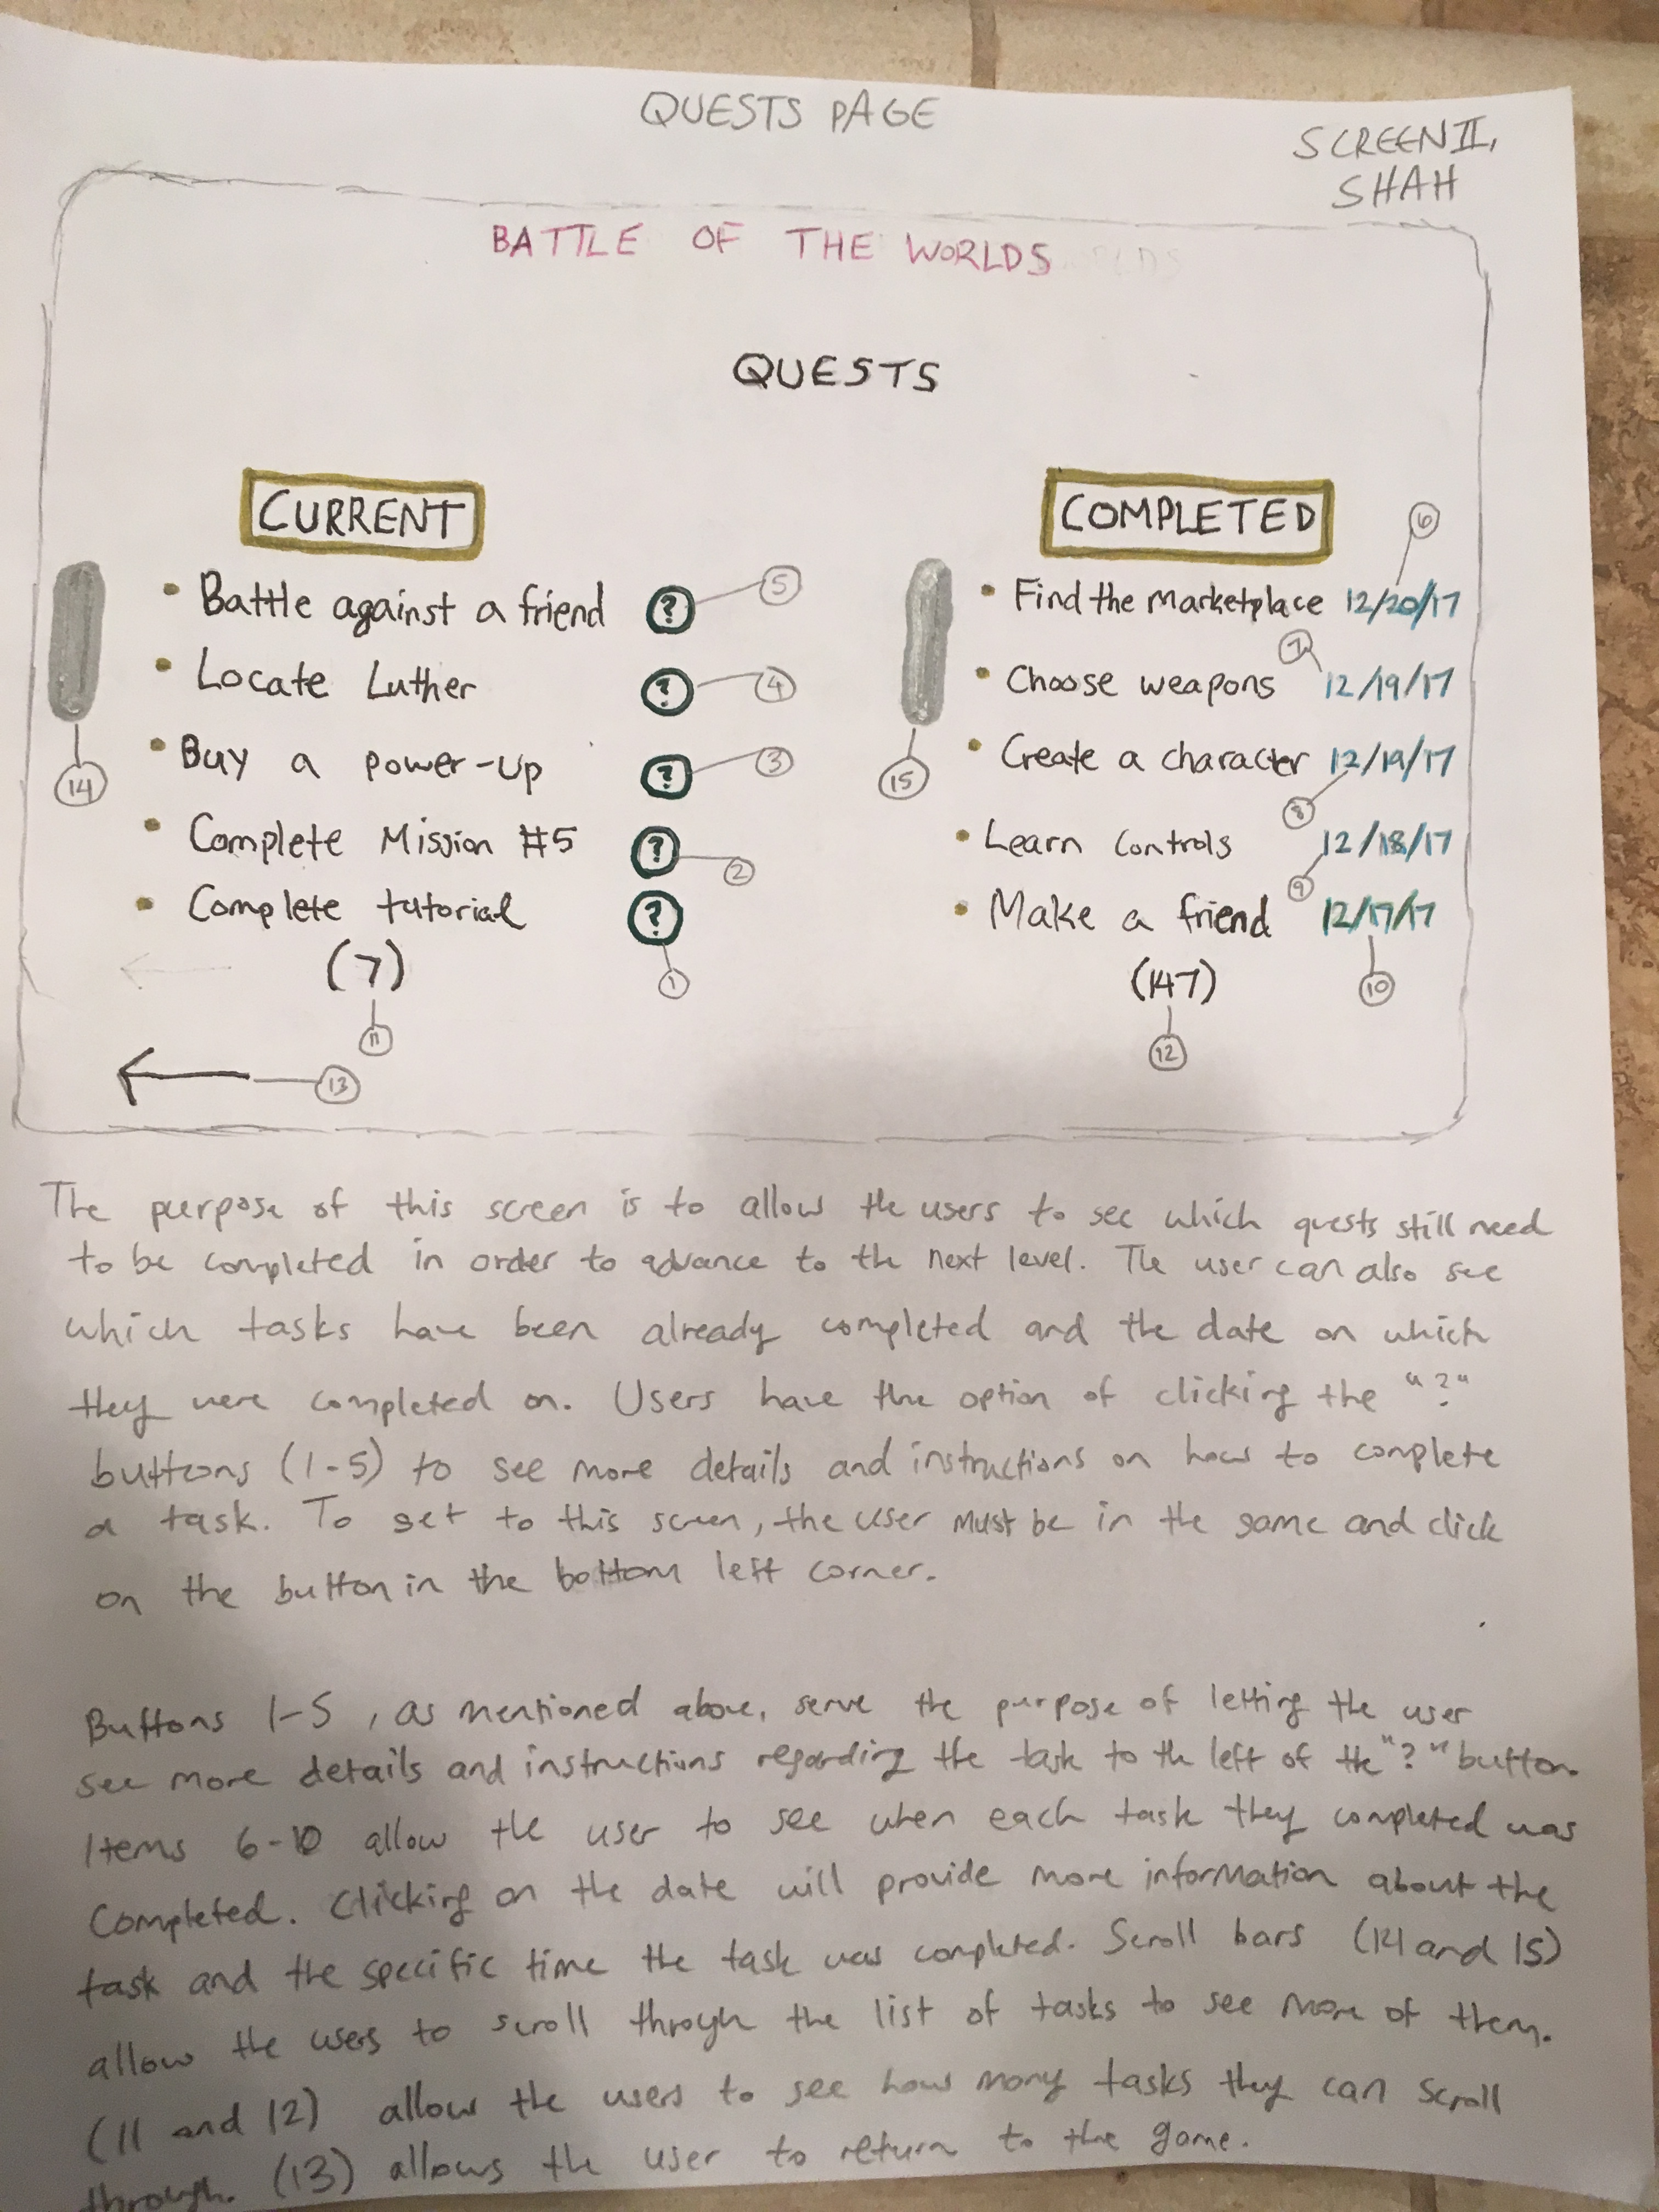

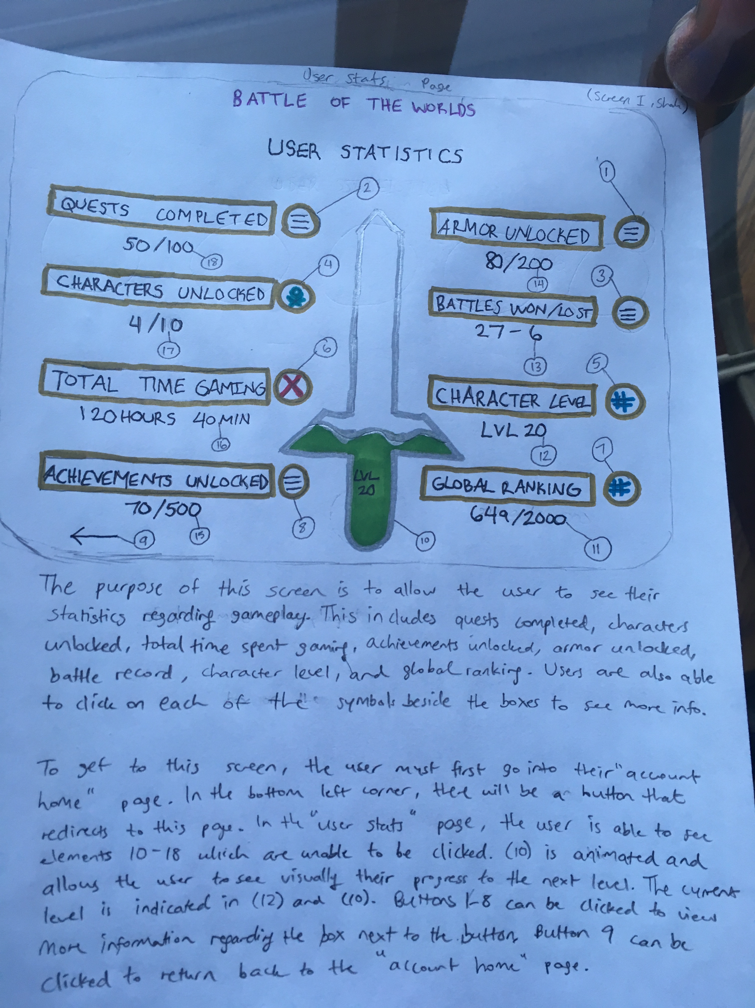

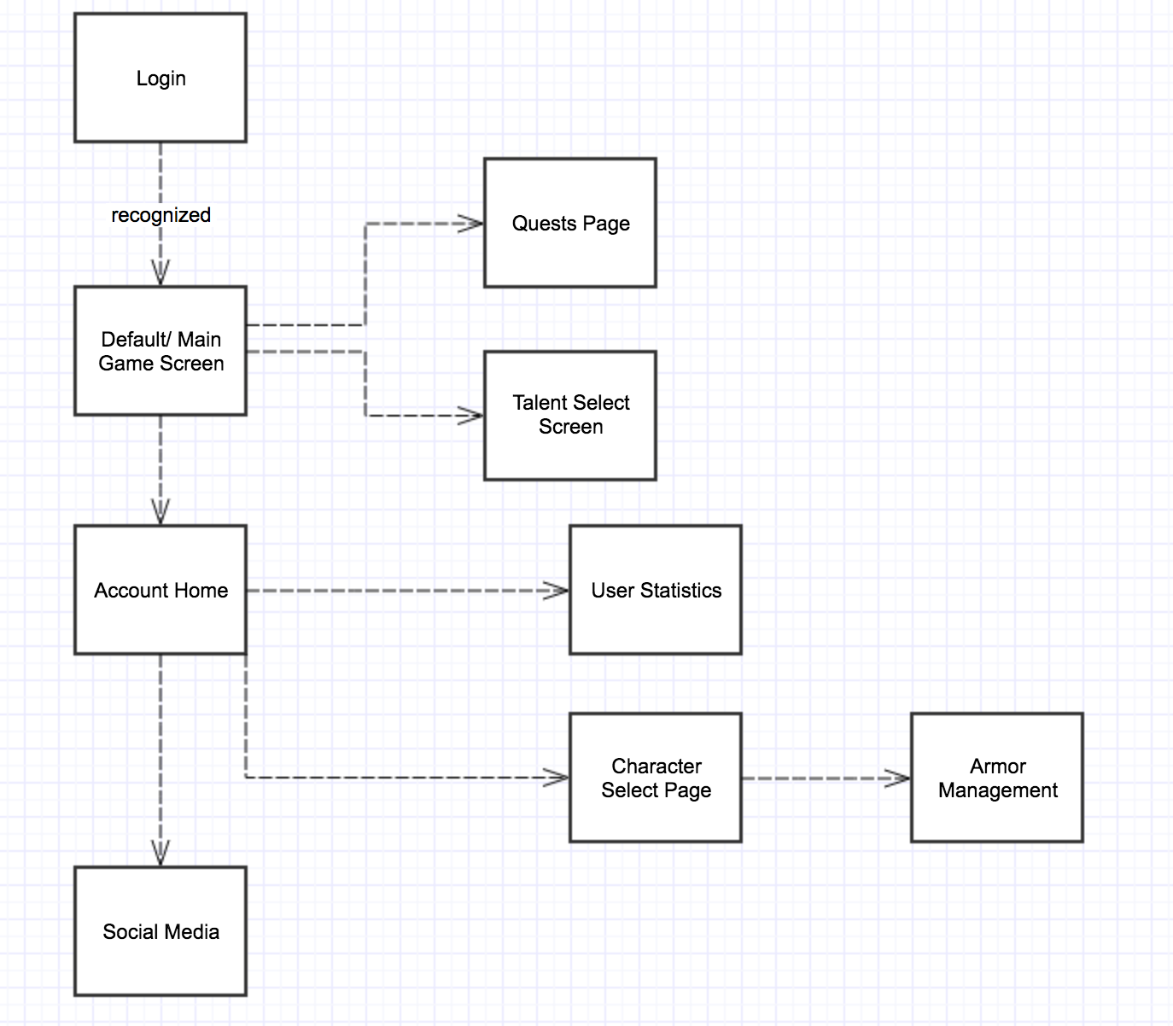**STEP 4- Flow Charts**

**Flow Chart of Screen Sketches**

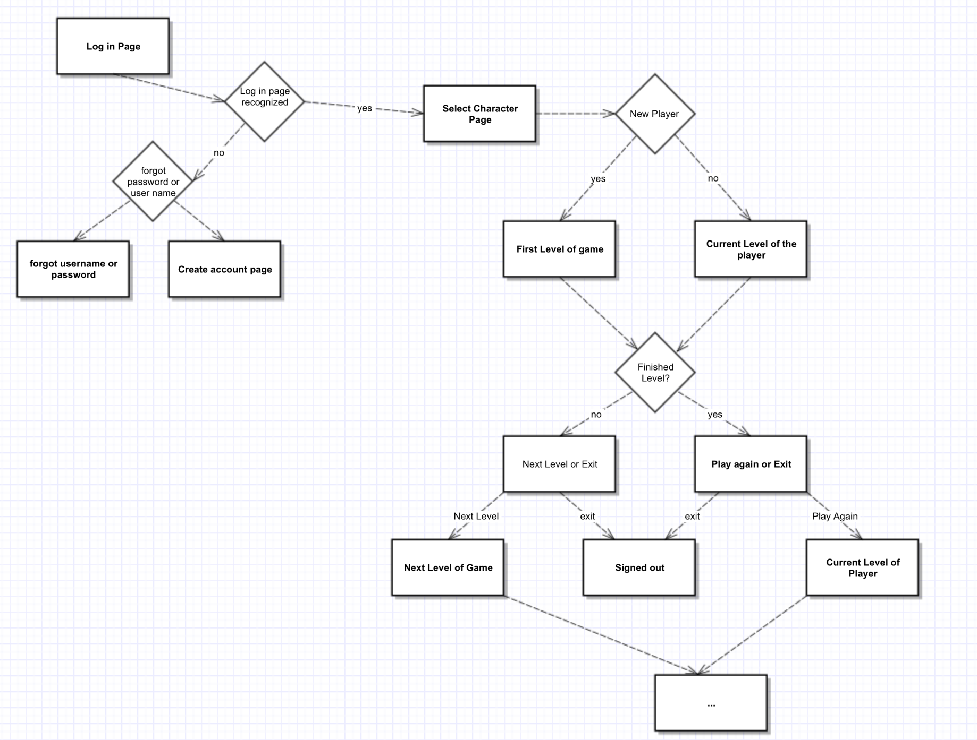

**Flow Chart of General Implementation of Game**

**STEP 5- Nonfunctional Requirements**

1. Reliability- how well the program functions overall and making sure that the game doesn’t break. The tester and admin will be in charge of this.
2. Maintainability- Making sure that as upgrades progress, the overall reliability is effective. This will be the tester and admins responsibility.
3. Security- Making sure that the game data and codes are not compromised while the game is active. This will be the game admin and the game testers duty to keep checking.

Side Note- If the tester and/or admin come across any issues the programmers will be fixing the issue and getting it approved again.

**STEP 6- Tables and Fields**

List of Tables/Fields

* Accounts Table
  + Database ID
  + Username Field
  + Password Field
* Character Info Table
  + Database ID field relating to Player in Accounts Table
  + 11 fields for armor and 6 fields for power ups containing the JSON data for the character
  + 1 Field for Character Type containing JSON data
* Map Data Table
  + Map Data for the game in JSON format
* NPC Table
  + NPC info in JSON format
* Game Data Table
  + Chat Page field in JSON format
  + Character Select Page in JSON format
  + Character Management Page in JSON format

Instruction Page in JSON forma